**ICS3U Final Project: Design Document**

**Rock, Paper, Scissors Game.**

Particulars (What is the program?):

This particular program will be a rock, paper, scissor game. The game will be designed for people of all ages. The purpose is for anyone who is bored to be able to play the game and enjoy it. This game can also be played at family events, school events and could be a nice addition to public places e.g. a mall. This game allows the user to compete in a best of 3 rock, paper, scissors game against the computer. The user is first welcomed to the game, then asked which of the three options they would like put up against the computer. The computer then places one of the three options randomly and checks for the winner. A point is added to the winners’ tally, the first person to two points wins.

Methods:

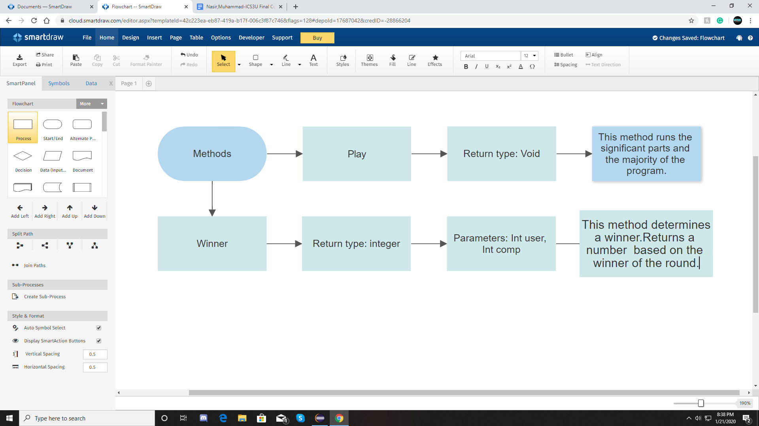

**Visuals (Program Flow Chart):**

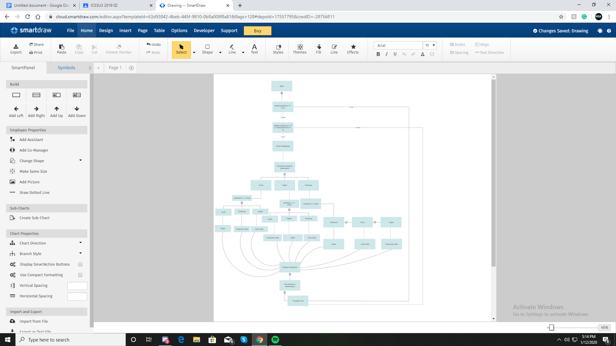

Description: The diagram above shows the process that the computer goes through when the program is running. Once the program is launched, firstly the rules are displayed. Secondly, computer random is generated and then the user input is taken. After the input is scanned, the “pictureDraw” method is called upon and the images are displayed. The winner is then determined through the “determineWinner” method. This process is followed until one of the two players reaches two points. The user is then asked if they want to play again. If the user enters “yes” then the game restarts and if they enter “no” the program ends.

**Output Visual:**

The following picture is an example of how the output of the program will look like(prototype).